PROGRESS REPORT KELOMPOK 3

Bootcamp Management

Selasa, 30 Januari 2019

Anggota :

Muhamad Ilham Habibie

M. Iqbal Aula Rahman

Proggress :

1. Baru buat 6 master data kurang 13 master data dan sudah jadi 1 interface untuk coba Login , Menu HR untuk Insert table Department masih kendala dalam udpdate datanya.

2. Target besok, selesaiin semua master datanya.

3. Untuk mengerjakan WPF bagian Microservice Data Access sudah jadi Model, Param, Database dan tablenya.

|  |  |  |  |  |  |  |  |
| --- | --- | --- | --- | --- | --- | --- | --- |
| **NAMA** | **MODUL** | **Master Data** | **INSERT** | **READ** | **UPDATE** | **DELETE** | **SEARCH** |
| ilham | achievement |  |  |  |  |  |  |
| batch | v | done | done | done | done | done |
| class |  |  |  |  |  |  |
| dailyscore |  |  |  |  |  |  |
| detaillesson |  |  |  |  |  |  |
| placement | v | done | done | on progress | on progress | on progress |
| room | v | done | done | done | done | done |
| historydetaillesson |  |  |  |  |  |  |
| lesson |  |  |  |  |  |  |
| iqbal | department | v | done | done | done | done | done |
| organization |  |  |  |  |  |  |
| employee | v | done | done | on progress | on progress | on progress |
| errorbank |  |  |  |  |  |  |
| schedule |  |  |  |  |  |  |
| skill | v | done | done | done | done | done |
| skillstudent |  |  |  |  |  |  |
| student |  |  |  |  |  |  |
| taskscore |  |  |  |  |  |  |
| workexperience |  |  |  |  |  |  |

1. ERD

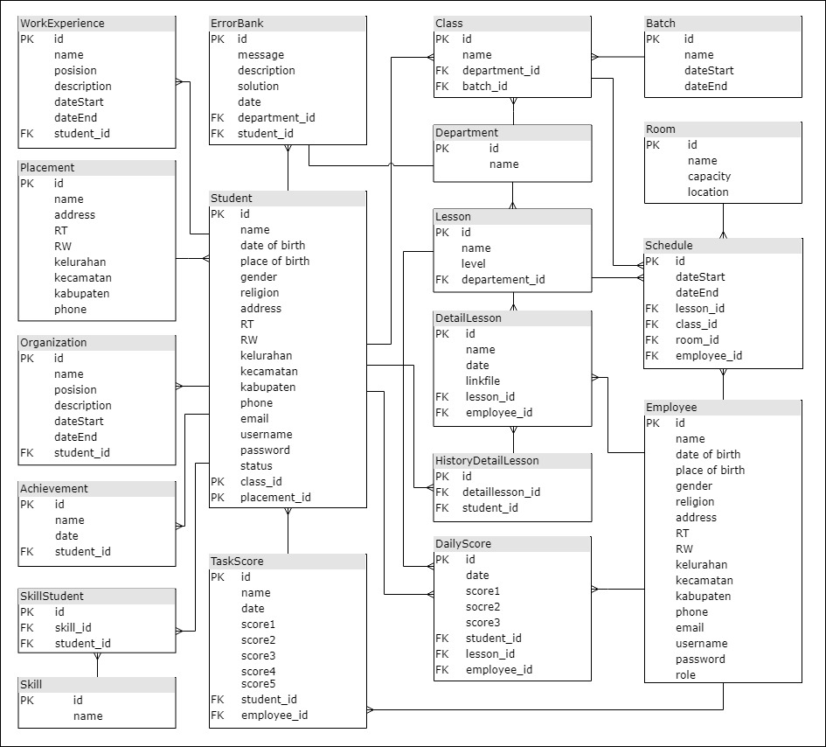

1. Use Case Diagram

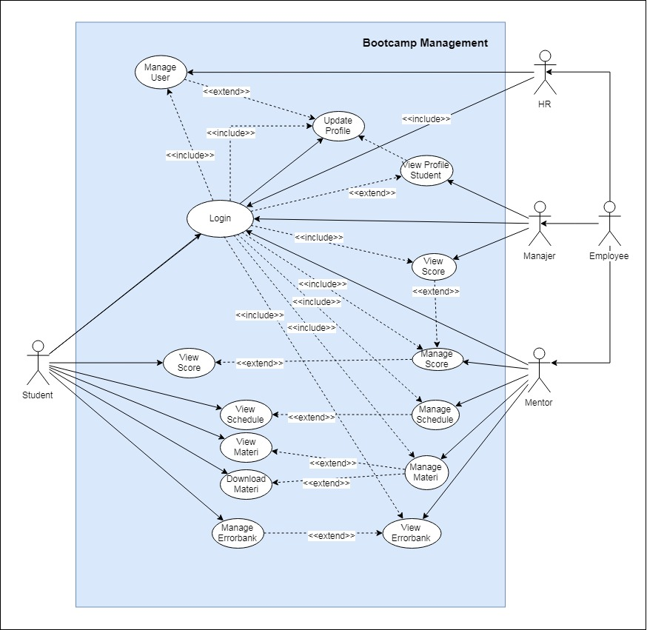

1. Class Diagram

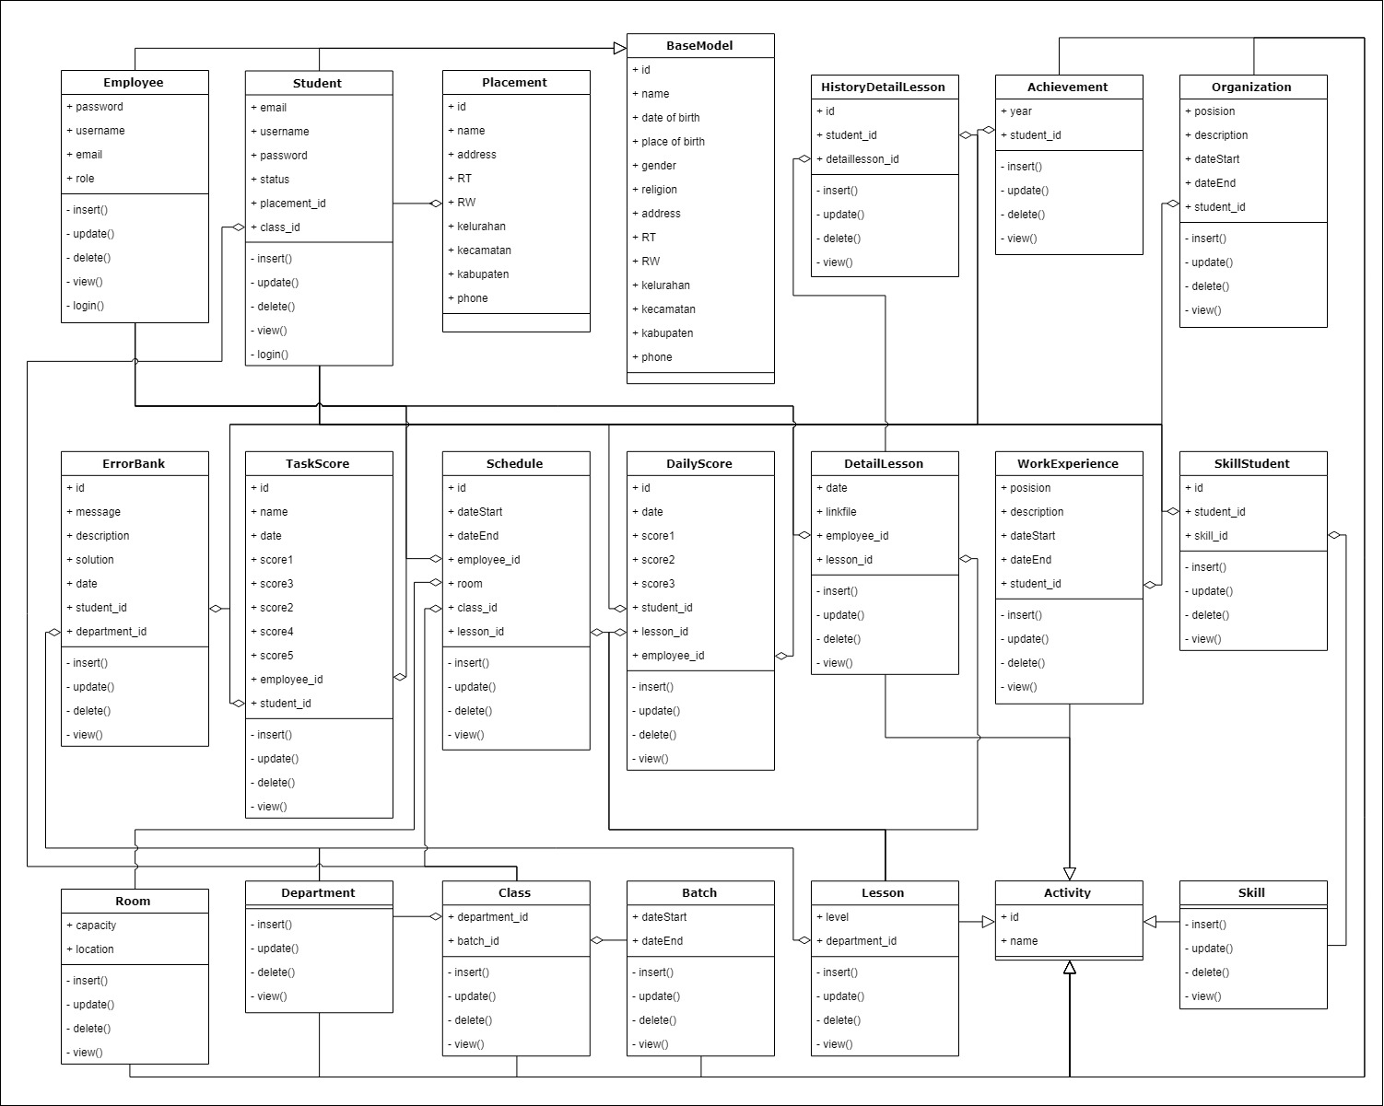

1. Activity Diagram

* HR – Login & HR – Add Manager

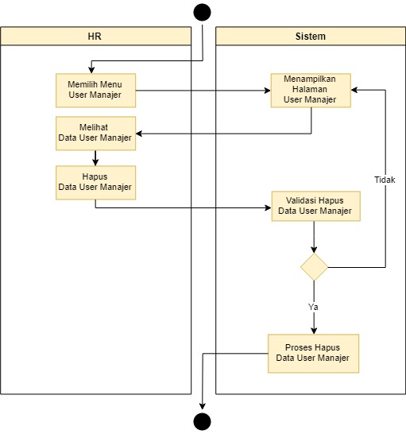 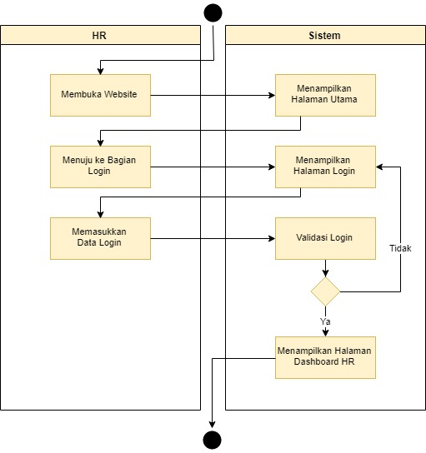

* HR – Update Manager & HR – Delete Manager

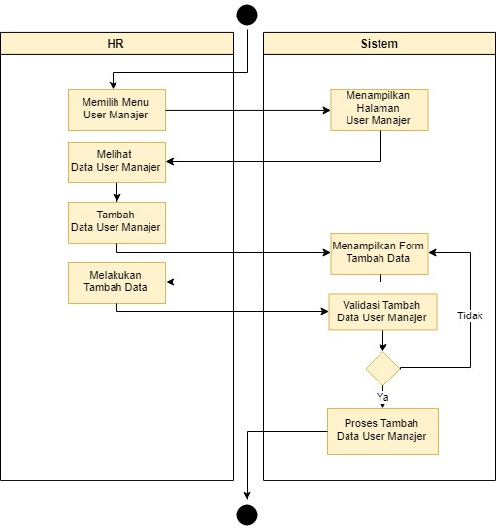 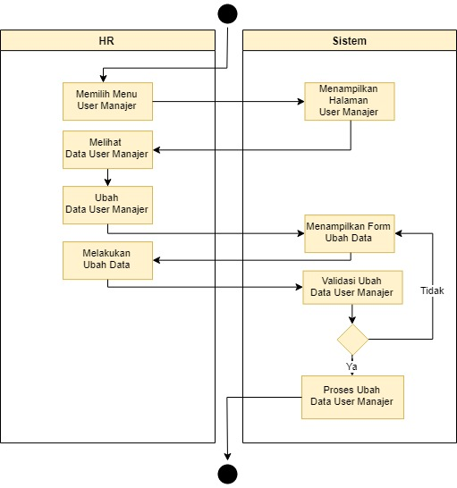

1. WPF Progress

